**Virtual Environments – Report Group H**

**Models:**

The first challenge was the models. The group needed to create models and find models online that would run on a mid-range mobile device. This ultimately meant, an environment with a low poly count. The vehicles, and other models would need to be quite minimal in terms of detail for this to work. The team kept this in mind and discussed what models would be suitable for use in the environment. The team was able to develop some models for use in the environment, as well as source some of the more difficult models to create, on the web. The team made sure that the models had a low poly count, ensuring minimal lag when the application was running, and meant creating the models would be easier.

**Navigation:**

It had been mentioned in one of the earlier lectures that teleportation could be used to navigate the environment. However, upon further research, this didn’t seem feasible, nor necessary. Thankfully, the assignments covered gazed based movement, which sufficed for what the group needed to accomplish.

**Purchase Process:**

Purchasing a car requires a player to choose a car, colour, and purchase the car. A failsafe also needed to be implemented for when the player walked into the buy area in a case where car had not been selected. Setting up the UI to display the chosen car and colour would mean those values could be stored in a variable. From here if a car is selected, we could display a purchase message, displaying the car name and colour from the variables. An if check was added to verify a car was selected by checking if the variables were empty. If they are not empty, the purchase notification is displayed on the screen.

**Collision:**

Normal collisions work perfectly for kinematic bodies, but not with ARVR origin. A clever way of solving this is to set up an area node around the player model and create a script that moves the player in the opposite direction that they are currently moving in when they collide with an object. This also means adding normal collisions to all other models.

**UI:**

The code and text elements of the UI were present on Moodle and in the labs. The group needed a way to change the text based on selected vehicles and performing the buy action. The solution was to rename the text labels, allowing the text to be modified based on the interaction component discussed in the lab. When a user enters a collision body, the text is changed, based on the box that was entered.

**Interaction:**

Interaction scripts were provided in the Godot laboratory sessions. They showcased how to trigger some event when walking into an area. With this information, the team was able to come up with a method of providing the interaction by placing multiple buttons on the floor of the dealership and attaching scripts to them to facilitate the actions required.

**Special Features:**

Each car would need to have a pre-set number of colours to be able to change to and some form of functionality to carry out this change. Scripts were created to facilitate this, in addition to resources used in the final laboratory session, which covered interaction. Buttons were added on the ground such that when the player walked over them, the colour of the car would change and be stored. Simply, the material is changed on the body of the car when the user enters the collision for that specific colour in the specific scene for the vehicle. A script was also developed to spin the cars around on the platform, such that they can be inspected fully, without the player needing to move.

**Conclusion:**

The group worked very well together and there were no stresses in getting everything done in time. All group members played their part and had some laughs along the way. Overall, the group enjoyed developing a virtual reality project, and can now use this as a portfolio project for future employers, showcasing not only design and programming skills, but showing that they worked swiftly and effectively as a team to compile the components into a working application.

**Individual contributions:**

**HUGO CAFFERTY:**

Hugo designed the models for the main desk, the office chair, and the regular chair. Hugo sourced the car models and came up with a solution for changing the car models, using the “areas” on the ground. Hugo designed scripts for changing and saving the colours and display the selected colour and vehicle on the UI, in addition to another script that would make the cars spin on the platforms. Hugo also designed the “Buy” script, which is triggered when the user walks over the “buy” button. This changes the text on the screen to show a purchase notification for the vehicle, again displaying the car name and the colour. Hugo developed the collision script. Hugo added in any extra models that the team designed towards the end of the project. Hugo also provided a video of the application running and compiled the “.apk” for the lecturer.

**SEAN KENNETH MAGUIRE:**

Sean spent time designing the “tire stack” model, as well as laying out some of the design elements for the environment, including a general rule of where things should be placed in the environment. Sean also added in the skybox to the world to work with the windows created in the environment. Sean also worked on creating lighting for the dealership, adding different lighting effects to add immersion and achieve higher presence.

**NIAMH EMMA CONNOLLY:**

Niamh put some time into designing a beautiful infographic for the project, showcasing all aspects of the project, including the logo, showcasing the products, the customisation, the environment, and the process of customising and purchasing the selected car. Niamh also designed some of the models, including “bamboo”, “tree”, “cactus”, and “cleaner”. She uploaded drafts of the infographic and asked for the teams input on how it should be formatted. Niamh took the initiative to update the infographic as the project changed.

**PADRAIG HALSTEAD:**

Padraig designed the stands for “Colour” and “Buy”, in addition to the car dealership itself. Padraig also created a GitHub repository for the group to upload and manage files. Padraig compiled the models created by the team into the finished environment, including the designed models, models from the web, and scripts developed by Hugo and the scripts for locomotion from the lab assignments. This gave the project a base for other members to work on scripts, add lighting, extra models, and the skybox around the outside.

**ASTLE MALCOLM CUTINHA:**

Astle designed a couple of models, including a cash register, a divider for the vehicles, and a carpet. Astle added these into the scene along with some of the other group members models. Astle also worked on creating lighting for the dealership.

**Infographic:**

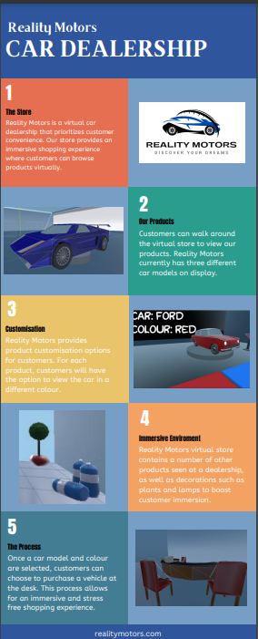

**References / Sources:**

**Low poly sports car:** “Low poly race car game ready” by “damonfury3” [**https://www.blendswap.com/blend/20642**](https://www.blendswap.com/blend/20642)

**Ford Angila:** “Ford Angila | Low poly car” by “sudeepsingh” [**https://www.blendswap.com/blend/25003**](https://www.blendswap.com/blend/25003)

**Suzuki Mariti:** “Low Poly Taxi” by “sudeepsingh”[**https://www.blendswap.com/blend/28524**](https://www.blendswap.com/blend/28524)

**Simple Computer:** “Retro computer” by “senmurai” <https://www.blendswap.com/blend/26625>

**Skybox: “**Kloofendal 48d Partly Cloudy (Pure Sky)**”** by “Greg Zall” and “Jarod Guest”<https://polyhaven.com/a/kloofendal_48d_partly_cloudy_puresky>

**VR Player Locomotion:** <https://moodle.maynoothuniversity.ie/pluginfile.php/1228586/mod_resource/content/0/VRPlayerLocomotion.gd>

**VR HUD:**

<https://moodle.maynoothuniversity.ie/pluginfile.php/1228584/mod_resource/content/0/VRDebugHUD.tscn>

<https://moodle.maynoothuniversity.ie/pluginfile.php/1228853/mod_resource/content/0/VRDebugHUD.gd>

**Interaction:**

<https://moodle.maynoothuniversity.ie/pluginfile.php/1231454/mod_resource/content/0/Lamp.gd>

**OpenVR module:** <https://godotengine.org/asset-library/asset/150>

**Appendix on Group Contributions**

**HUGO CAFFERTY:**

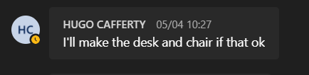

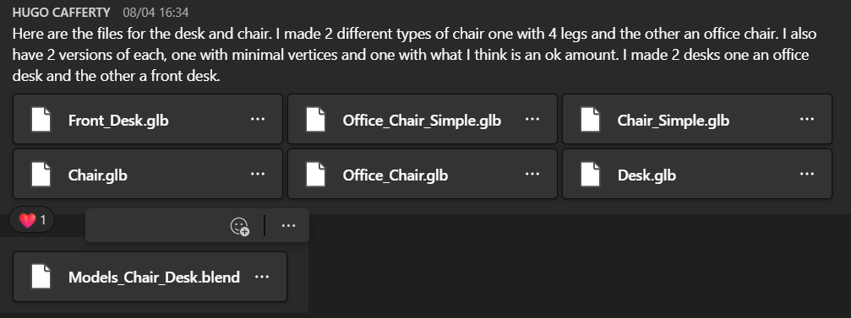

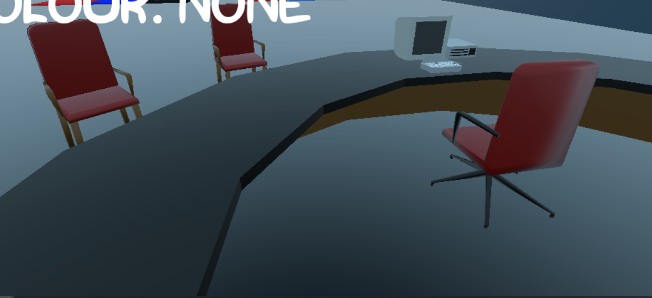

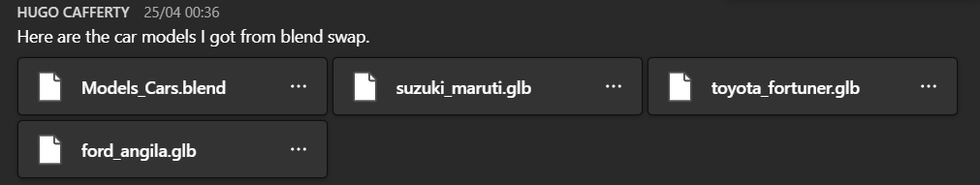

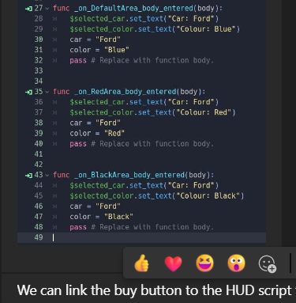 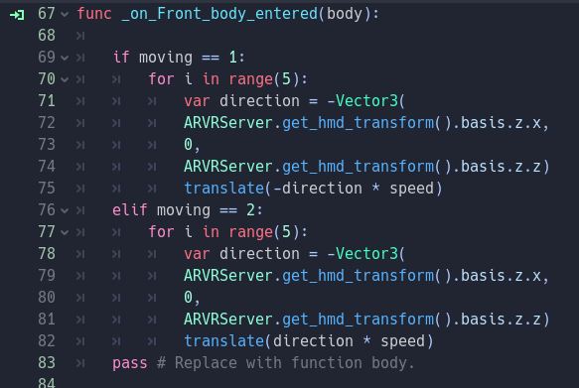

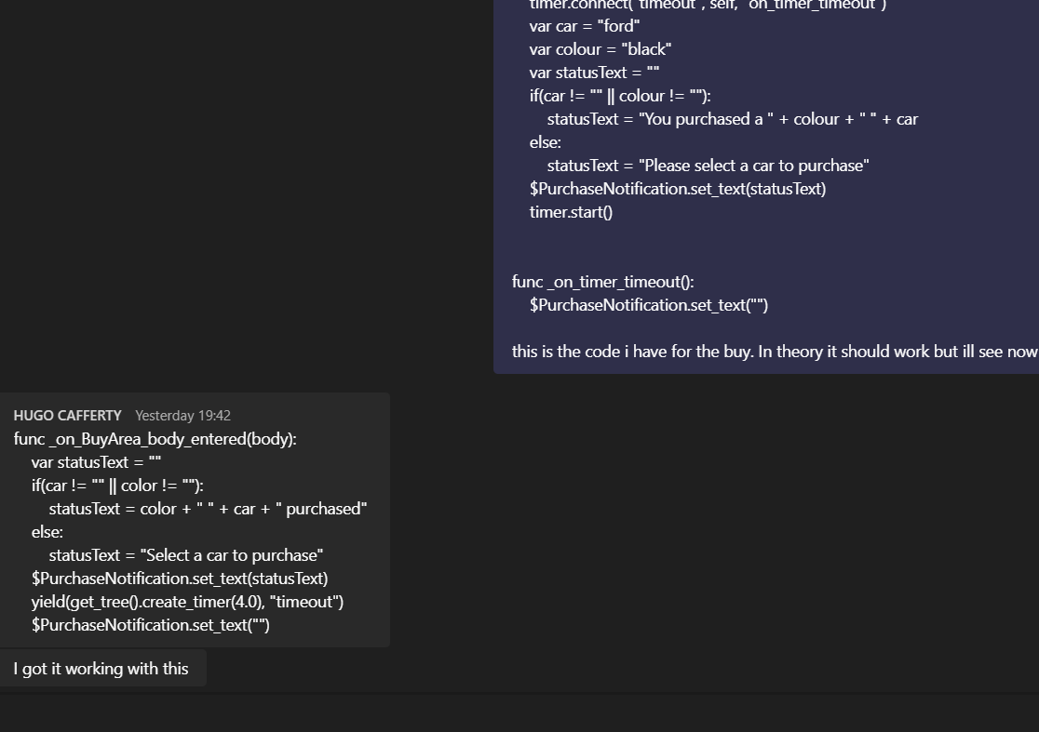









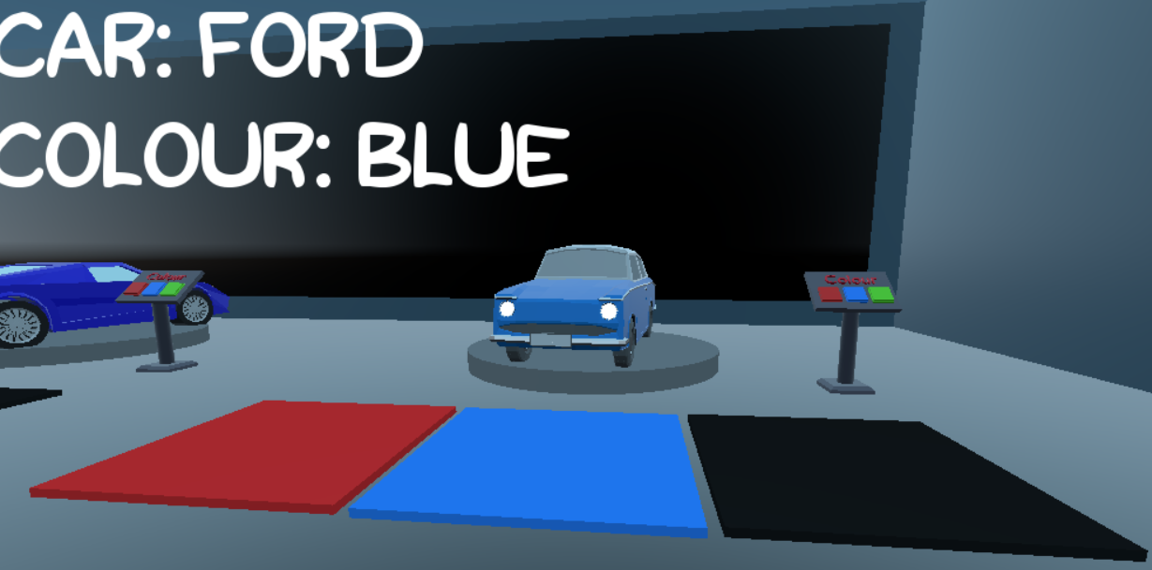

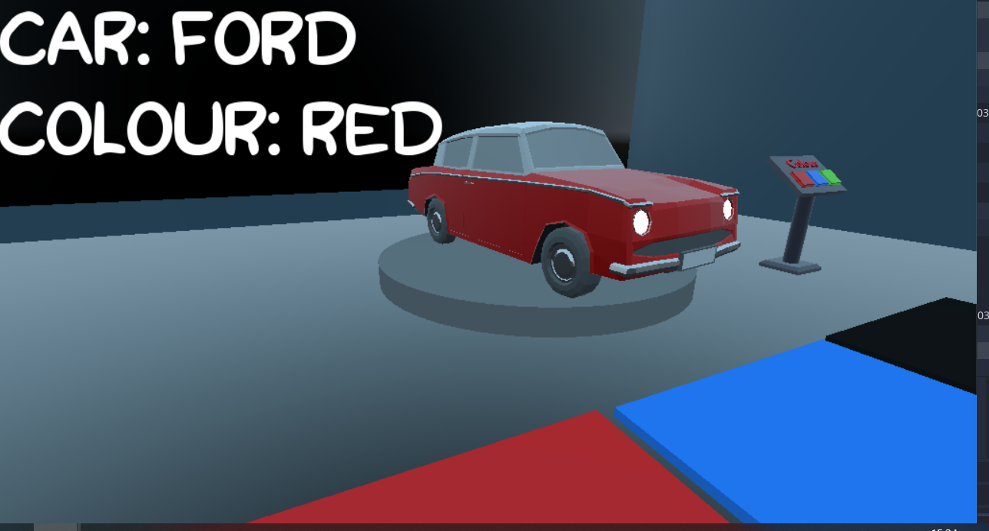

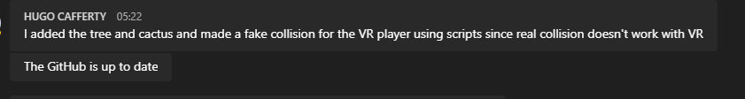

**SEAN KENNETH MAGUIRE:**



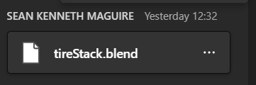

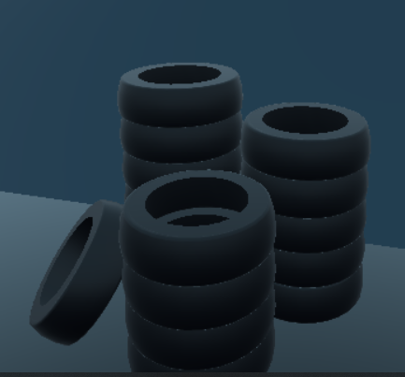

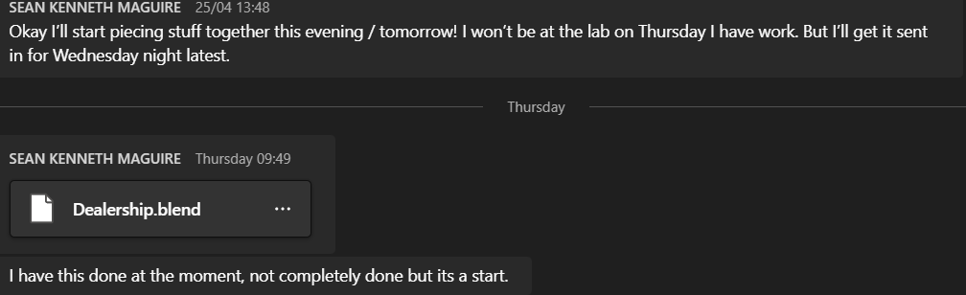

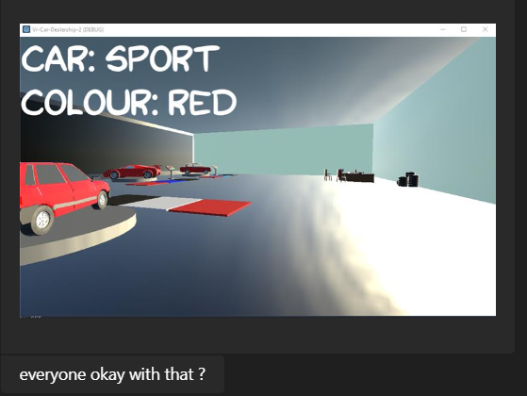

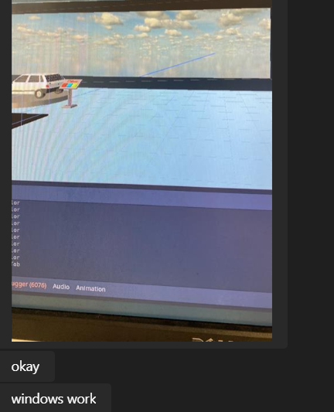



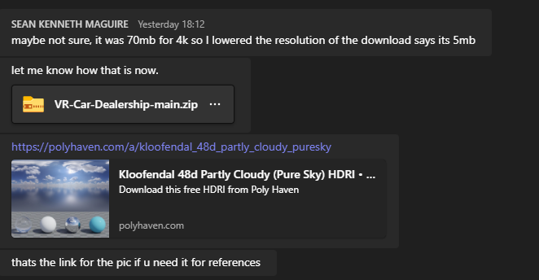

**NIAMH EMMA CONNOLLY:**

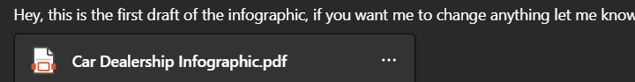

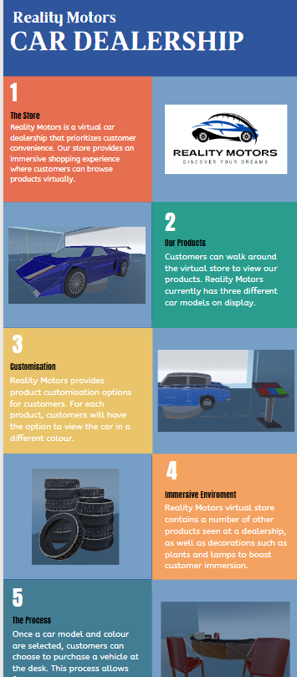

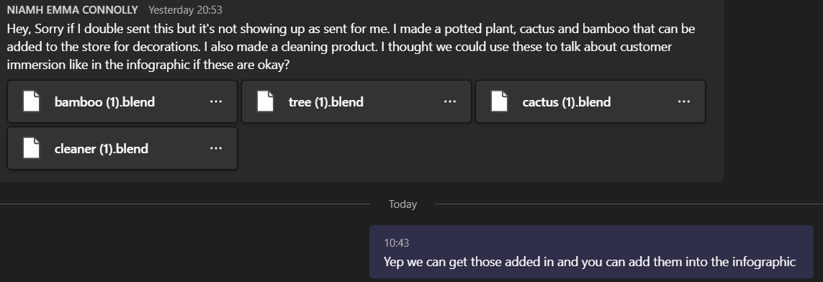

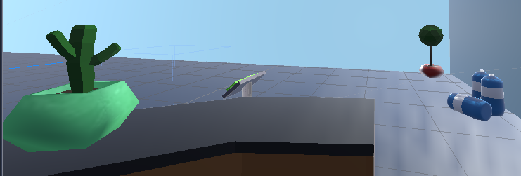

**PADRAIG HALSTEAD:**

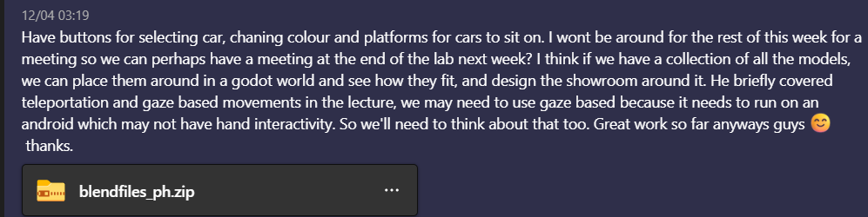

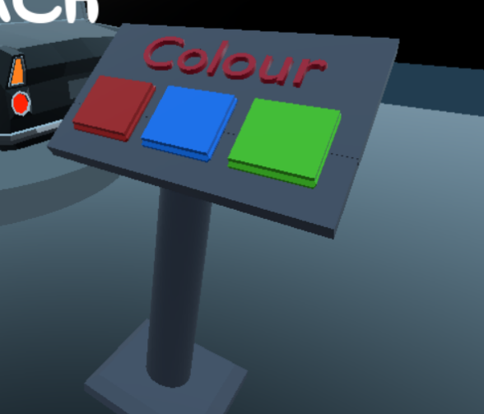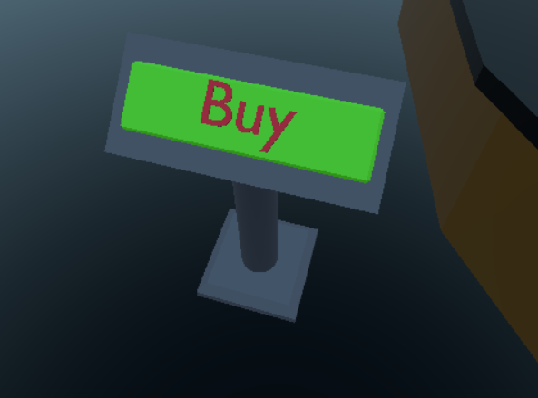

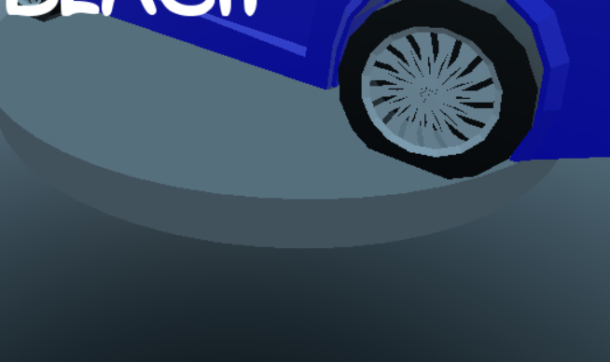

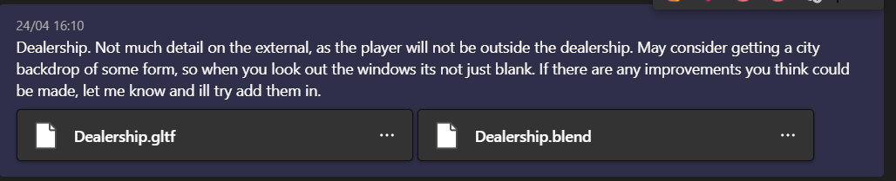

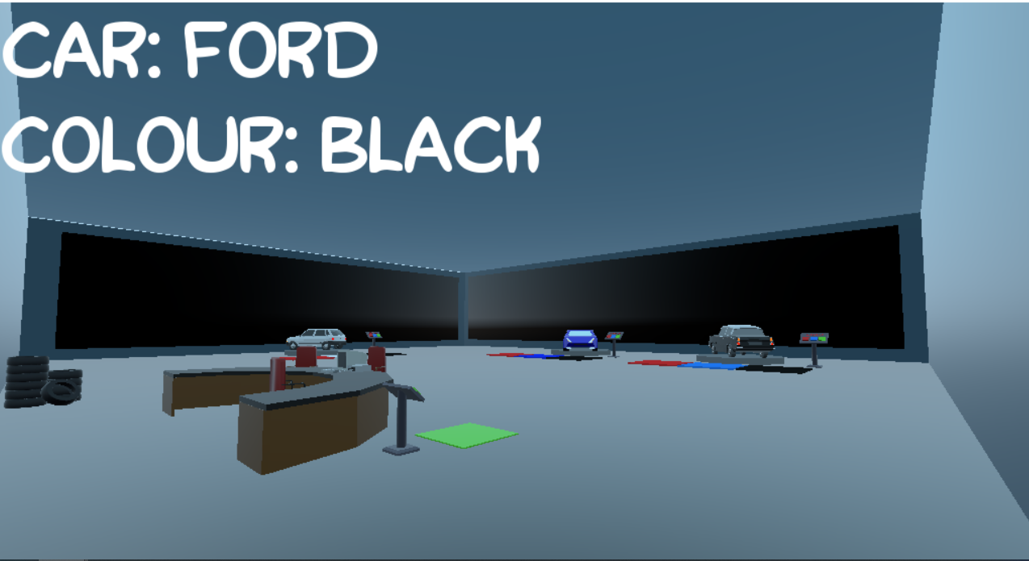



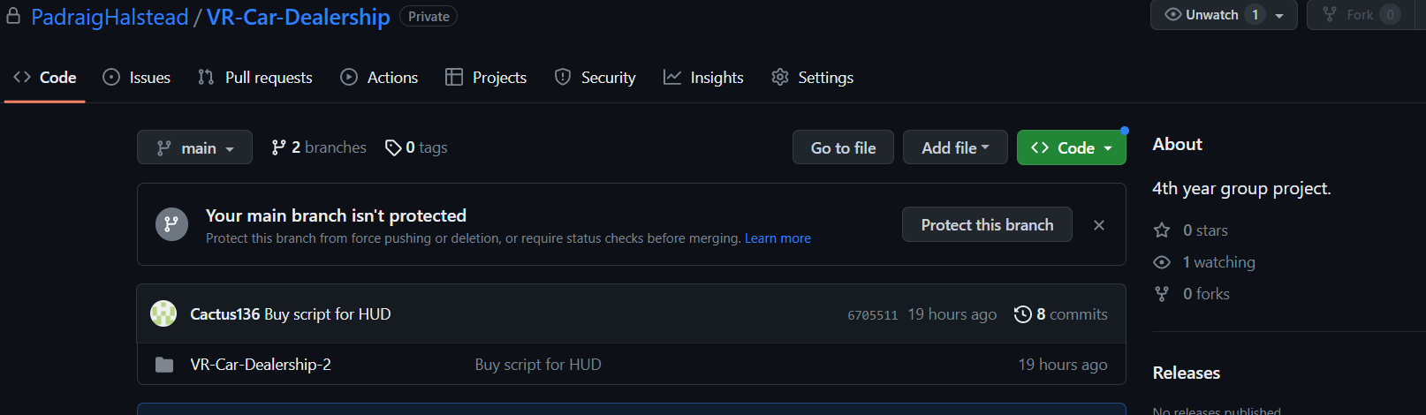

**ASTLE MALCOLM CUTINHA:**



